Module 2 - Data structures and Algorithms
Exercise 2: E-commerce Platform Search Function

i)Understanding Asymptotic Notation:
- Big O Notation:
Big O notation describes how the running time of an algorithm grows as the input size (n) increases. It helps compare algorithms based on efficiency.

Examples:
- O(1) → Constant time
- O(log n) → Logarithmic time
- O(n) → Linear time
- O(n²) → Quadratic time

ii)Search Operation Cases:

Case | Linear Search |  | Binary Search
Best Case | O(1) |  | O(1)
Average Case | O(n) |  | O(log n)
Worst Case | O(n) |  | O(log n)
- Best Case: Element found at the beginning or middle immediately.
- Average Case: Element found after several comparisons.
- Worst Case: Element is last or absent.

Program Code:
Product Class:
package Ecommerce_Platform;

class Product {
int productId;
String productName;
String category;

Product(int productId, String productName, String category) {
this.productId = productId;
this.productName = productName;
this.category = category;
}

void display() {
System.out.println(productId + " " + productName + " " + category);
}
Linear Search:

package Ecommerce_Platform;

public class LinearSearch {

public static Product linearSearch(Product[] products, int key) {
for (Product p : products) {
if (p.productId == key) {
return p;
}
}
return null;
}

public static void main(String[] args) {

Product[] products = {
new Product(101, "Laptop", "Electronics"),
new Product(102, "Shoes", "Fashion"),
new Product(103, "Phone", "Electronics"),
new Product(104, "Watch", "Accessories")
};

Product result = linearSearch(products, 103);

if (result != null)
result.display();
else
System.out.println("Product not found");
}
}

Output:

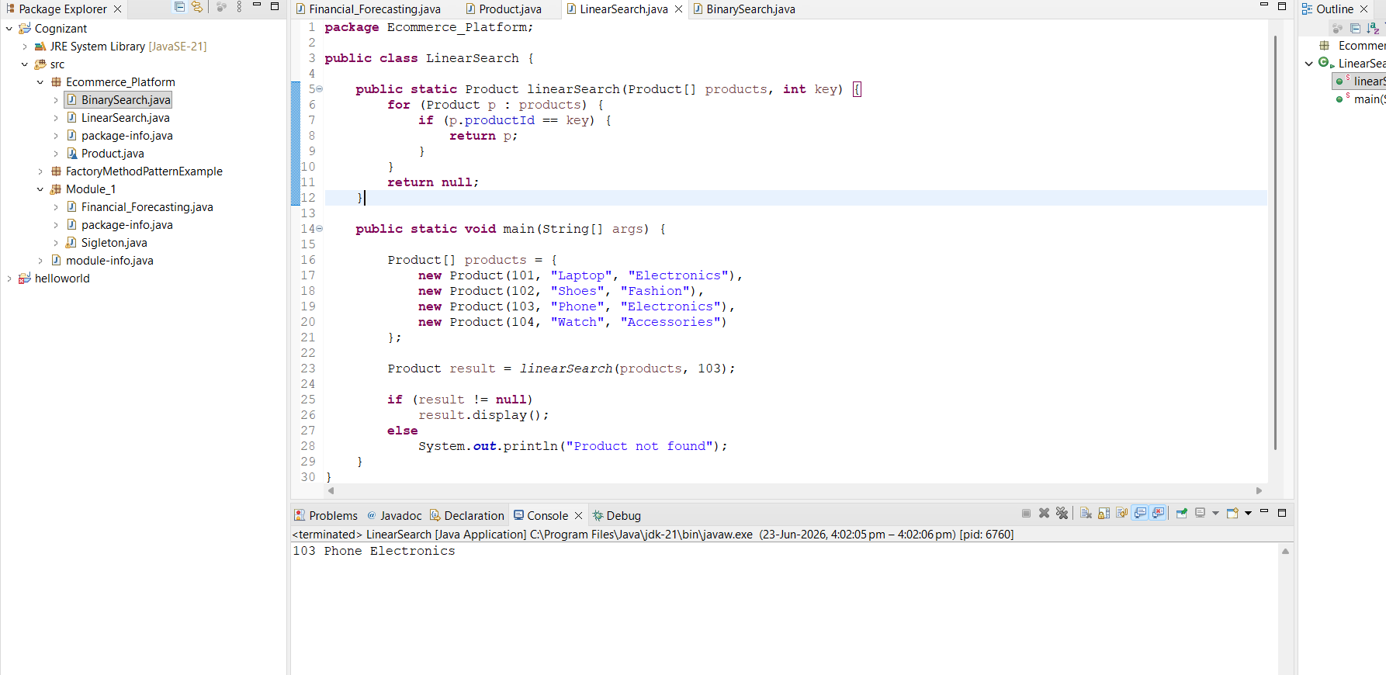

Binary Search :

package Ecommerce_Platform;

public class BinarySearch {

public static Product binarySearch(Product[] products, int key) {
int low = 0;
int high = products.length - 1;

while (low <= high) {
int mid = (low + high) / 2;

if (products[mid].productId == key)
return products[mid];
else if (products[mid].productId < key)
low = mid + 1;
else
high = mid - 1;
}

return null;
}

public static void main(String[] args) {

Product[] products = {
new Product(101, "Laptop", "Electronics"),
new Product(102, "Shoes", "Fashion"),
new Product(103, "Phone", "Electronics"),
new Product(104, "Watch", "Accessories")
};

Product result = binarySearch(products, 103);

if (result != null)
result.display();
else
System.out.println("Product not found");
}
}

Output:

